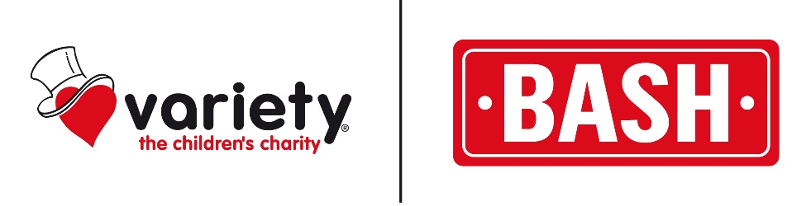

SA VARIETY BASH  
14 – 21 August 2021  
Little Italy to Big Italy



Lunch & Night Stops

**Day Date Lunch Night**

Start Line SA Produce Markets, Pooraka

Day 1 Sat 14th Caltowie Quorn

Day 2 Sun 15th Blinman Leigh Creek

Day 3 Mon 16th On Route Innamincka SA

Day 4 Tues 17th Innamincka (Seafood Lunch) Innamincka SA

Day 5 Wed 18th Noccundra QLD Thargomindah QLD

Day 6 Thurs 19th Eulo QLD Hungerford QLD

Day 7 Fri 20th Louth NSW Cobar NSW

Day 8 Sat 21st Goolgowi NSW Griffith NSW