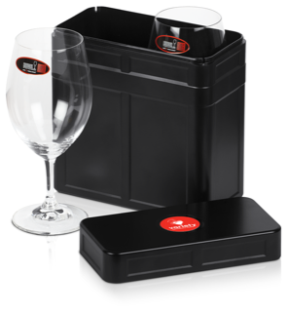 **Variety 4WD Car 222**

**Enjoy your wine with a touch of glass!**

***No matter where you roam, be it land or sea or foam you will always partake of your chosen wine from these magnificent Riedel Ouverture Magnum wine glasses which nestle safely in this cleverly designed valise!***

This South Australian designed and manufactured treasure has been selected for your enjoyment as you Sponsor Rod and me, the Wondering Wombats of Car 222, in the Variety SA 4WD Adventure and MOTO Run - raising money for special needs children in our state.

|  |
| --- |
| **Cost per Box - inclusive of container and glasses: *$80.00 + 10% GST* with Variety logo**  **+ *delivery in Australia $10.00***  Contact Person: ___________________________________ No of boxes: _________________  Delivery address: _______________________________________________________________  Suburb: _____________________________ State: ______________ Postcode: _____________  Mobile:__ __________________________________Email: __________________________________ |

* I have paid by Direct Deposit the amount of $_____________into Car 222’s Variety’s Bendigo Bank A/c
* ACC Name : Variety Tent 75 BSB 633 000 Acct #: 175 100 858 Ref: 4WD21/222
* I hereby authorise my credit card to be charged with $________________ Visa or Mastercard
* Card Number; _ _ _ _ _ _ _ _ _ _ _ _ _ _ _ _ Expiry Date: _ _ / _ _
* Name on Card: ____________________________ Signature: ___________________________
* I have enclosed a cheque for $________________ (made payable to Car 222)

**Kindly return completed form to: Sue Pearce, Car 222** 111/123 Fisher Street, Fullarton SA 5063 or email to: [suepearce222@gmail.com](mailto:suepearce222@gmail.com)

0417857241 for collection by appointment - if preferred