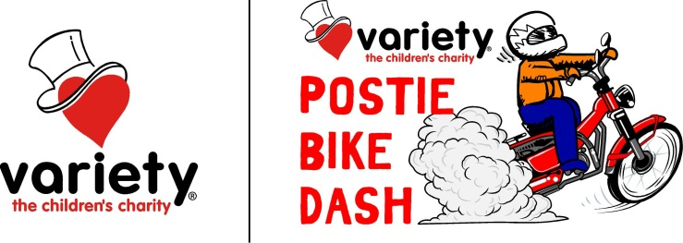

Variety Postie Bike Dash Bike & Rider Requirements

The Bike

* The bike must be presented in the form of a standard Honda CT110 Motorcycle in every aspect including the rear rack, mudguards and engine crash plate.
* Rims are to be standard CT110, however your tyre selection is unrestricted as long as they fit the standard rims and clear the standard mudguards.
* Front suspension may be improved provided all improvements are housed within the standard fork tubes and sliders.
* Rear suspension may be improved but no modifications are to be made to mounting or shock travel.
* Exhaust can be modified at will but not exceed legal decibel levels set by State laws.
* Carburettor must be standard.
* Air cleaner can be changed, however, please be aware the substitution for a more open system may leave the engine vulnerable to dust intake in most conditions we will be riding in.
* Fuel to be standard pump fuel with a maximum octane of 98.
* Engine horsepower must not exceed the manufacturers 7.6 H P (5 kW).

The Rider

* Must be a minimum of 18 years of age.
* Must hold a current motorcycle licence (NO LEARNERS PERMITS).
* Must attend nominated checkpoint day.
* Must wear an approved motorcycle helmet with some form of chin protection (NO OPEN FACE HELMETS).
* Must wear closed in footwear, gloves, long trousers, protective jacket and fluro vest provided.
* Must sign an indemnity form.
* Must have paid entry fee 7 days prior to departure.
* Must have paid provisions fee 7 days prior to departure.
* Must abide by road rules as prescribed by State Laws and Statutes.
* Transmission must be standard.
* Drive sprockets can be changed.
* Handlebars are to be standard or a similar bar style and any changes must meet Roads and Marine regulations.
* No modification is allowable to brakes.
* Must have a container the approximate size of a milk create mounted on the rear rack to display sponsors’ signage and carry a 5 litre fuel container with the appropriate fuel to suit your bike, drinking water and a basic first aid kit.